2. SPRING-REST-HANDSON

1)Hello World RESTful Web Service

Code:

HelloController.java:

**package** com.cognizant.spring_learn.controller;

import org.springframework.web.bind.annotation.GetMapping;

import org.springframework.web.bind.annotation.RestController;

@RestController

public **class** HelloController {

@GetMapping("/hello")

public String sayHello() {

return "Hello World!!";

}

}

Output:

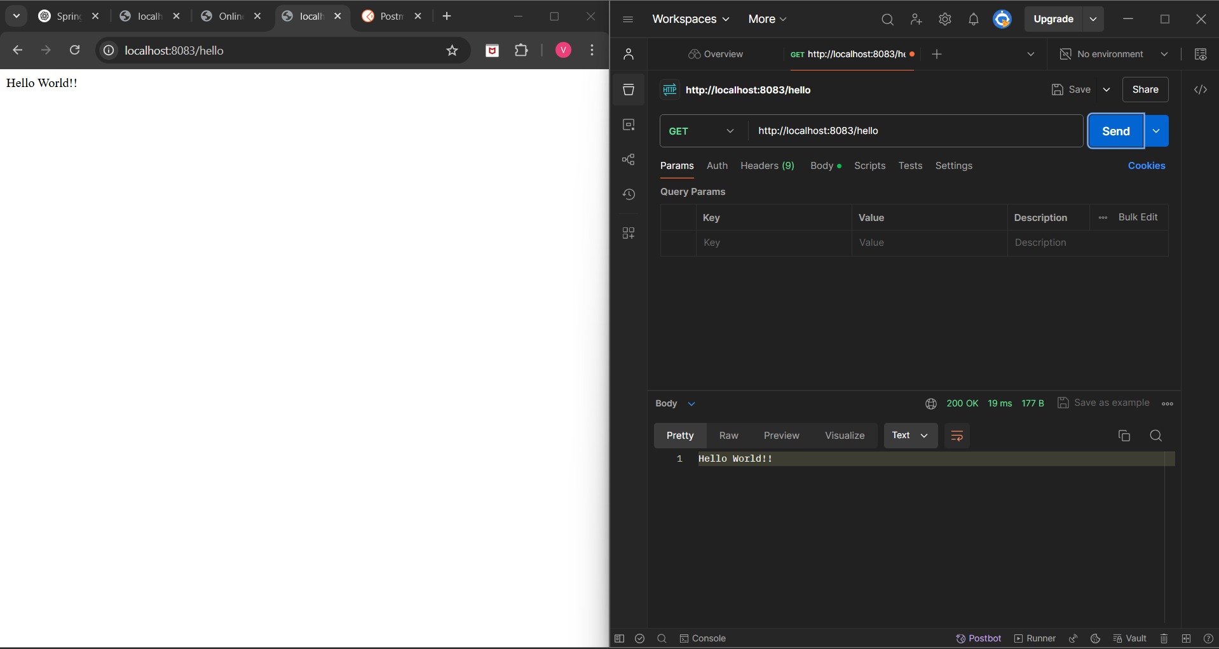

2)REST - Country Web Service

Code:

CountryController.java:

**package** com.cognizant.spring_learn.controller;

import com.cognizant.spring_learn.Country;

import org.slf4j.Logger;

import org.slf4j.LoggerFactory;

import org.springframework.beans.factory.annotation.Autowired;

import org.springframework.context.ApplicationContext;

import org.springframework.web.bind.annotation.RequestMapping;

import org.springframework.web.bind.annotation.RestController;

@RestController

public **class** CountryController {

private static final Logger LOGGER = LoggerFactory.getLogger(CountryController.class);

@Autowired

private ApplicationContext context;

@RequestMapping("/country")

public Country getCountryIndia() {

LOGGER.debug("START");

Country country = context.getBean("country", Country.class);

LOGGER.debug("Country: {}", country);

LOGGER.debug("END");

return country;

}

}

country.xml:

<?**xml** version="**1.0**" encoding="UTF-8"?>

<beans xmlns="http:**//**www.springframework.org/schema/beans"

xmlns:xsi="http:**//**www.w3.org/2001/XMLSchema-instance"

xsi:schemaLocation="http:**//**www.springframework.org/schema/beans

http:**//**www.springframework.org/schema/beans/spring-beans-3.1.xsd">

<bean id="country" class="com.cognizant.spring_learn.Country">

<property name="code" value="IN"/>

<property name="name" value="India"/>

</bean>

</beans>

Output: 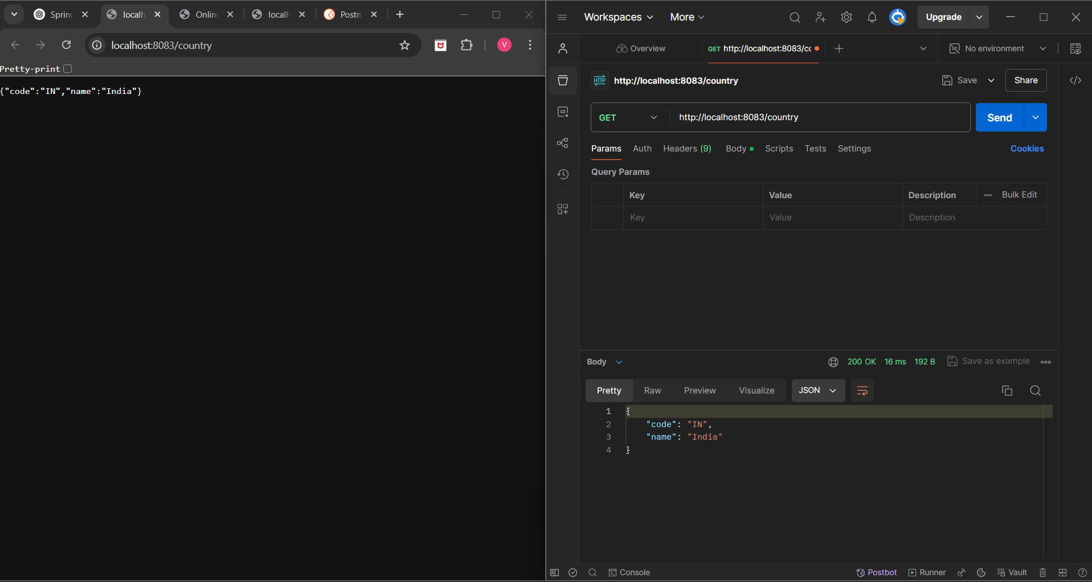

3) REST - Get country based on country code:

Code:

CountryController.java:

**package** com.cognizant.spring_learn.controller;

import com.cognizant.spring_learn.Country;

import com.cognizant.spring_learn.service.CountryService;

import org.slf4j.Logger;

import org.slf4j.LoggerFactory;

import org.springframework.beans.factory.annotation.Autowired;

import org.springframework.web.bind.annotation.*;

@RestController

public **class** CountryController {

private static final Logger LOGGER = LoggerFactory.getLogger(CountryController.class);

@Autowired

private CountryService countryService;

@GetMapping("/country/{code}")

public Country getCountry(@PathVariable **String** code) {

LOGGER.debug("START");

Country country = countryService.getCountry(code);

LOGGER.debug("Country found: {}", country);

LOGGER.debug("END");

return country;

}

}

CountryService.java:

**package** com.cognizant.spring_learn.service;

import com.cognizant.spring_learn.Country;

import org.springframework.beans.factory.annotation.Autowired;

import org.springframework.context.ApplicationContext;

import org.springframework.stereotype.Service;

import java.util.List;

@Service

public **class** CountryService {

@Autowired

private ApplicationContext context;

public Country getCountry(String code) {

List<Country> countryList = context.getBean("countryList", List.class);

return countryList.stream()

.filter(country -> country.getCode().equalsIgnoreCase(code))

.findFirst()

.orElse(null);

}

}

country.xml:

<?**xml** version="**1.0**" encoding="UTF-8"?>

<beans xmlns="http:**//**www.springframework.org/schema/beans"

xmlns:xsi="http:**//**www.w3.org/2001/XMLSchema-instance"

xsi:schemaLocation="http:**//**www.springframework.org/schema/beans

http:**//**www.springframework.org/schema/beans/spring-beans-3.1.xsd">

<bean id="countryList" class="java.util.ArrayList">

<constructor-arg>

<list>

<bean class="com.cognizant.spring_learn.Country">

<property name="code" value="IN"/>

<property name="name" value="India"/>

</bean>

<bean class="com.cognizant.spring_learn.Country">

<property name="code" value="US"/>

<property name="name" value="United States"/>

</bean>

<bean class="com.cognizant.spring_learn.Country">

<property name="code" value="JP"/>

<property name="name" value="Japan"/>

</bean>

</list>

</constructor-arg>

</bean>

</beans>

Output: